**R5Objective**

Tic-Tac-Toe is a staple of childhood games. The rules are simple and the logic that governs the game is straightforward. This project helps you to create a functioning version of Tic-Tac-Toe that can be played by two humans. The graphical part of the project has been taken care of for you; your focus will be to develop the logic that governs the gameplay of the grid (a 2D array). By the end of the project you will be proficient at implementing methods that access and evaluate conditionals with elements in a 2D array.

**Collaboration**

This assignment is to be completed in pairs with a Housemate and you are to employ the Pair Programming technique. You and your partner are to honor the [Collaboration Policy](http://drive.google.com/open?id=1Asy1hOfuwYIPpWPWym_UQp5EIZGHJtWHH2U7VXhRyck) throughout this assignment. For this project, you may choose your own partner. **You will need to join a group on Canvas**.

**Project Setup**

Go to the Unit 6 page on Canvas and download the TicTacToeStarterCode.zip folder and place its contents inside the AP CS/Unit 6 - 2D Arrays/TicTacToe Project directory. When you unzip TicTacToeStarterCode, you’ll see that there is one Java file in the folder--the TicTacToeGame class, and a README.txt. You’ll implement five methods to develop a functioning game of Tic-Tac-Toe in TicTacToeGame. To play a game of Tic-Tac-Toe, construct a TicTacToeGame object and call the playAGame method.

**Project Structure**

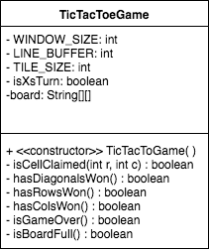

The UML diagram should help you get an understanding of how the project is organized.

The first section lists all of the fields in the class.

The second region has methods that you will need to implement.

The class already has some methods that I wrote for you. **Do not modify or alter these methods**. EVER. LIKE AT ALL. K THANKS. Those methods are responsible for handling the graphics and the user interacting with the game board.

**Project Structure**

* **Fields**
  + isXsTurn : a boolean that is true when the active turn belongs to Player X, and false otherwise
  + board : a 2D String array of size 3 by 3 that represents the markings of a Tic-Tac-Toe board.
    - If the square has been claimed by Player X, its value will be the String literal “X”.
    - If the square has been claimed by Player O, its value will be the String literal “O”.
    - If the square has not yet been claimed by either player, then it will be the default uninstantiated String value, null. Remember that! Calling methods on null objects results in a NullPointerException.
* **Methods**
  + public booolean isCellClaimed(int r, int c)
    - Returns true if board[r][c] is claimed by either Player X or Player O, and returns false otherwise.
  + public booolean hasDiagonalsWon()
    - Returns true if a diagonal of board has been claimed by Player X or Player O. The method returns false otherwise.
  + public booolean hasRowsWon()
    - Returns true if a row of board has been claimed by Player X or Player O. The method returns false otherwise.
  + public booolean hasColsWon()
    - Returns true if a column of board has been claimed by Player X or Player O. The method returns false otherwise.
  + public booolean isGameOver()
    - Returns true when the game has finished. A game of Tic-Tac-Toe is finished when either a player has won or the game has resulted in a tie. isGameOver() should call other methods in TicTacToeGame to determine if the game is finished. This can be accomplished in one single Java statement.
  + public booolean isBoardFull()
    - Returns true if all spaces in board have been claimed. If a square is still unoccupied, isBoardFull returns false. You need not concern yourself with identifying if the game will end in a tie before all 9 squares have been played.

1. By reading the UML diagram, identify the name of the variable that stores the Tic-Tac-Toe board. What is its data type?  
     
   The data type of the Tic-Tac-Toe board is a String[][].
2. What are the three types of values that can be assigned to a cell in the game board?   
     
   The three types of values that a cell could be assigned on the game board is “X”, “O”, or null.
3. Consider the hasRowsWon method. Identify the three cases in which this method returns true. What condition(s) must be met for hasRowsWon to return true?

The method returns true when 1) the first row (index of 0) has all the same values and are full (all “X” and all “O”) 2) the second row (index of 1) has all the same values occupy the cells in that row and all the cells are occupied (all “X” and all “O”) and 3) when the third row (index 2) has all the same values occupying the cells in that row and all cells are occupied in the designated row.

In order for hasRowsWon to return true, all of the cells in one row must be occupied, and once occupied, they must all have the same value (“X” or “O”…. not null).

1. What should your program do in the hasRowsWon method if the first row doesn’t yield a winner?  
   The method would have to look at the second row and the third row to see if there is a winner (the index for the first [] in board would increase). If the first, second, and third rows all return false (none of them have all cells in the row filled with the same value), then the hasRowsWon method would return false, and the program would move on to see if hasDiagonalsWon or hasColsWon return true. If any of the programs return true, the game is over.
2. What conditions must be satisfied in order for isGameOver to return true?

In order for isGameOver to return true, hasDiagonalsWon, hasColsWon, hasRowsWon, or isBoardFull must return true. If none of them return true, then the isGameOver method will return false, but if any of the conditions are met where any of the above methods return true, then isGameOver will return true.

**Challenge for the Bored (Challenge for the Board??? Get it??)**

1. Currently the game simply stops when a player has won the game. Add a nice visual effect of coloring the game board to match the color of the player (X is blue and O is red). See below for an example. This will require you to do a little more diving into the original source code as well as exploring the [StdDraw API](http://introcs.cs.princeton.edu/java/stdlib/javadoc/StdDraw.html).

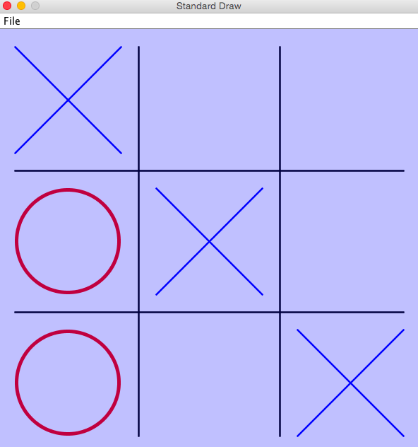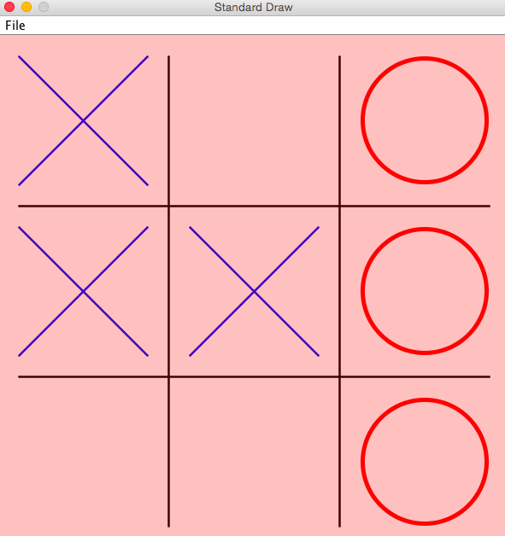

1. Traditionally when the game of Tic-Tac-Toe is played on paper, the winner strikes a line through their winning path. Add a feature to do the same. Again, you’ll need to rely on the [StdDraw API](http://introcs.cs.princeton.edu/java/stdlib/javadoc/StdDraw.html).  
     
   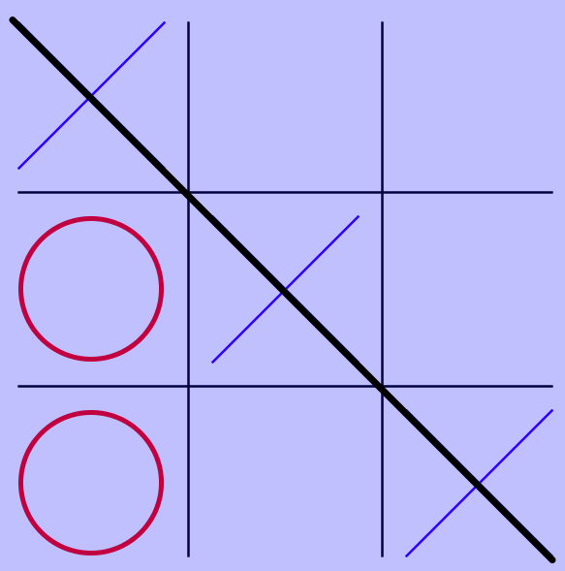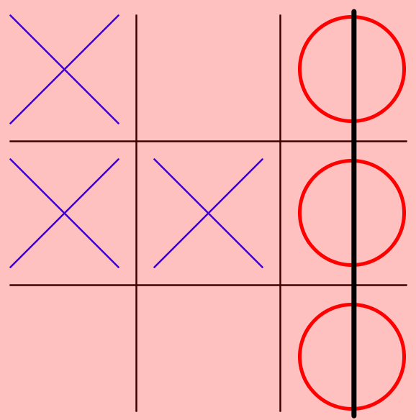
2. Add a feature at the conclusion of the game which prompts the user if they would like to play another game. If yes, restart a game of Tic-Tac-Toe. If not, wish them farewell.
3. Add a naive AI. The AI should randomly play an open cell on the board. The AI does not consider a best strategy, but rather chooses a cell at random.

If you’re curious for a conceptual understanding of a smarter AI, Google “Minmax Algorithm” and “Alpha Beta Pruning.” Do be aware that programming the Minimax Algorithm into your game is beyond the scope of this course. That Data Structures and Algorithms class, tho. 👍